ONLINE FOOD ORDERING SYSTEM

**1 .Register page:**

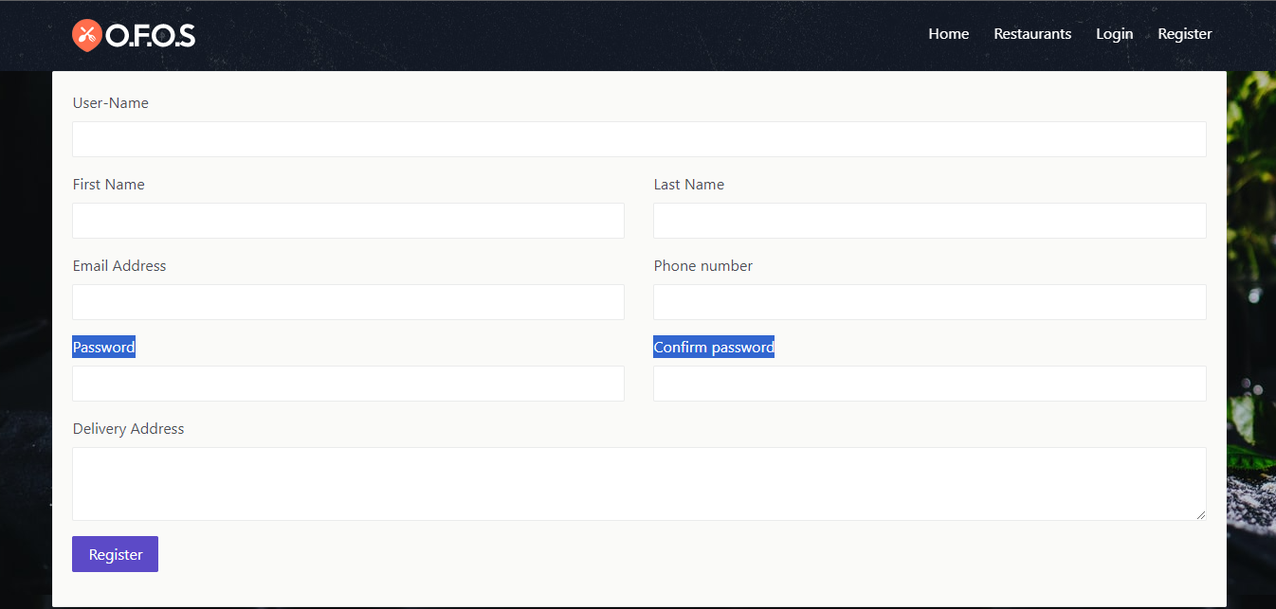

1 .1 “**First name**” text box should be present in the right side in register page.

1 .2 “**Email address**” text box should be present in the right side and under the “**first name”** text box in register page.

1.3 **“password”** Text Box should be present in the right side and under the **“Email address”** text box in register page.

1.4 **“Delivery address”** text box should be present in the right side and under the **“password”** text box in register page.

1.5 **“Last name”** Text Box should be present in the Top left side in register page.

1.6 **“Phone number”** text box text box should be present in the left side and under the **“Last name”** text box in register page.

1.7 **“confirm password”** text box text box should

Be present in the left side and under the

**“Phone number”** Text box in register page.

1.8 **“register”** button should be present in the bottom right corner in register page.

**2. LOGIN PAGE:**

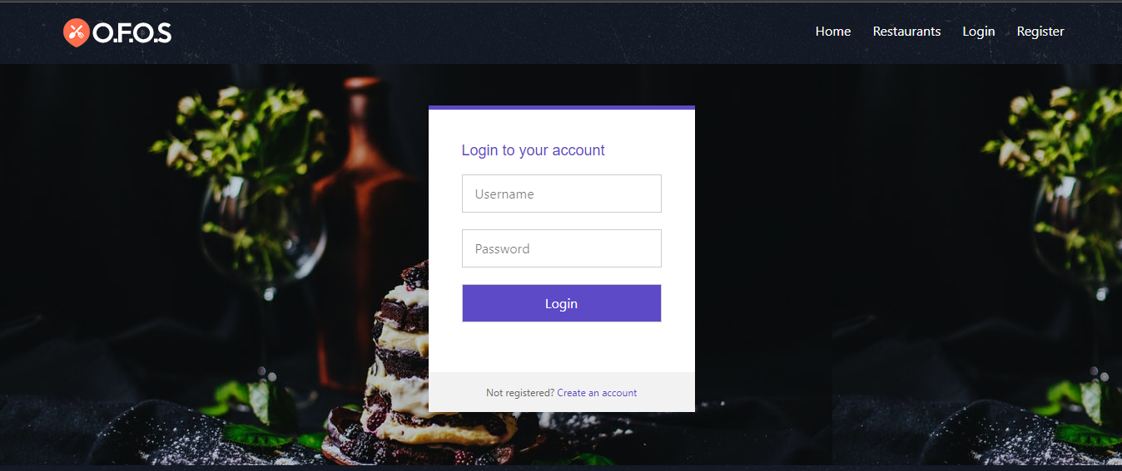

1.1 **“Username”** text box should be present in the centre align under  **“login to your account”** in login page.

1.2 **“password”** text box should be present in the centre align and under the **“username”** text box in login page.

1.3 **“login”** button should be present in the centre align under the **“password”** text box in login page.

1.4 **“Not registered? Create an account”** should be present in the bottom under the **“login”** button in login page.

**3. Admin panel**

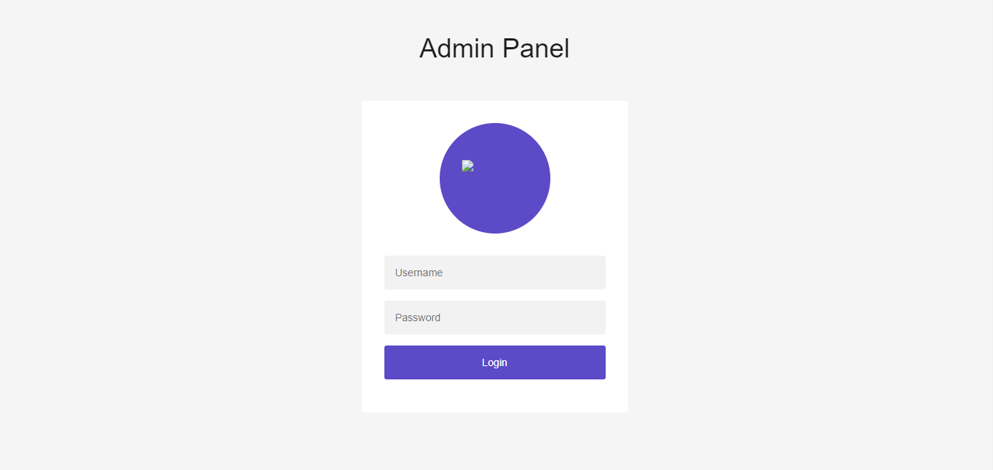

1.1 **“profile icon”** should be present in centre in admin panel.

* 1. **“Username”** text box should be present in the centre align under **“profile icon”** in admin panel.
  2. **“Password”** text box should be present in the centre align under **“user name”** text box in admin panel.
  3. **“Login”** button should be present in the centre align under **“password”** text box in admin panel.

**Logout:**

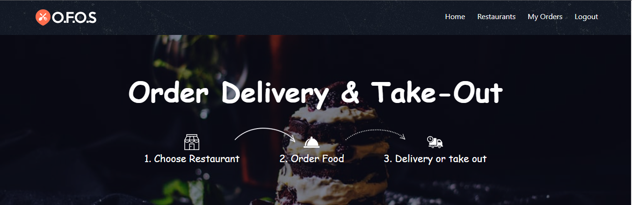

* 1. When User click on logout tab login page should be display.

